There are two dogs
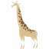
PL - ANJ 4.B Zvieratá, čísla
What is this? How many animals are there?

