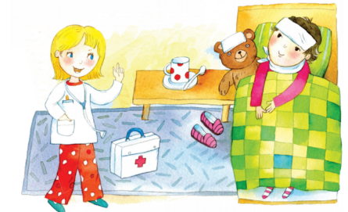
Pracovný list

Sisa má malú rybu.
---------------------------------------------------------------------------------------------------------------------------------------------------------------------------------------------------------------------------------------------------------------------------------------------------------------------------------------------------

Sisa je dobrá .
---------------------------------------------------------------------------------------------------------------------------------------------------------------------------------------------------------------------------------------------------------------------------------------------------------------------------------------------------

Moja mamka má tašku .
---------------------------------------------------------------------------------------------------------------------------------------------------------------------------------------------------------------------------------------------------------------------------------------------------------------------------------------------------
Boli sme doma .
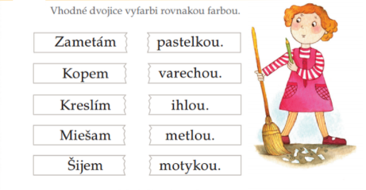
---------------------------------------------------------------------------------------------------------------------------------------------------------------------------------------------------------------------------------------------------------------------------------------------------------------------------------------------------

ČÍ | TAŤ | PÍ |  | ČE
PÍ |  | NO |  | HĽA
FÚ |  | VO |  | KO
PA |  | PÍS |  | KÚ

