***1.PL-15.3.2021- 0.A-*** Napíš prvú slabiku Meno_________________________________

C:\Users\student\AppData\Local\Microsoft\Windows\Temporary Internet Files\Content.IE5\ETOHOTS5\MC900308033[1].wmf C:\Users\student\AppData\Local\Microsoft\Windows\Temporary Internet Files\Content.IE5\8XJ8H54Q\MC900052617[1].wmf C:\Users\student\AppData\Local\Microsoft\Windows\Temporary Internet Files\Content.IE5\ETOHOTS5\MC900052825[1].wmf

C:\Users\student\AppData\Local\Microsoft\Windows\Temporary Internet Files\Content.IE5\XZUJBGCA\MC900199893[1].wmf C:\Users\student\AppData\Local\Microsoft\Windows\Temporary Internet Files\Content.IE5\VEEQTX4Q\MC900192149[1].wmf C:\Users\student\AppData\Local\Microsoft\Windows\Temporary Internet Files\Content.IE5\PU0U7IM2\MC900352144[1].wmf

Napíš písaných kamarátov

M __ E__ á __ L __ e __ A __ é__ Ema _____ mama ________ Lea______

Prečítaj tieto vety a prepíš ich

Ema má C:\Users\student\AppData\Local\Microsoft\Windows\Temporary Internet Files\Content.IE5\8XJ8H54Q\MC900325588[1].wmf.

Máme malé C:\Users\student\AppData\Local\Microsoft\Windows\Temporary Internet Files\Content.IE5\ETOHOTS5\MC900052805[1].wmf.

___________________________________

***2.PL-15.3.2021- 0.A-***

***I – MODROU***

***E – ČERVENOU***

|  |  |  |  |  |  |  |  |
| --- | --- | --- | --- | --- | --- | --- | --- |
| I | E | I | N | E | O | I | E |
| E | I | S | A | I | E | P | I |

i – MODROU

a – ČERVENOU

|  |  |  |  |  |  |  |  |
| --- | --- | --- | --- | --- | --- | --- | --- |
| a | i | L | a | I | a | P | i |
| a | i | R | a | i | a | I | i |
| i | a | i | L | S | i | L | a |
| i | a | I | K | a | i | J | i |

***3.PL-15.3.2021- 0.A-*** SPÁJAŤ

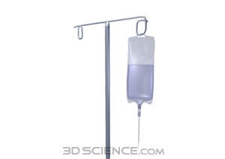

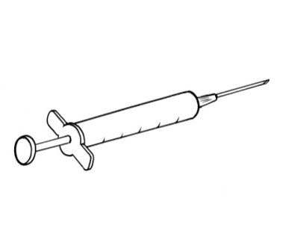



I

