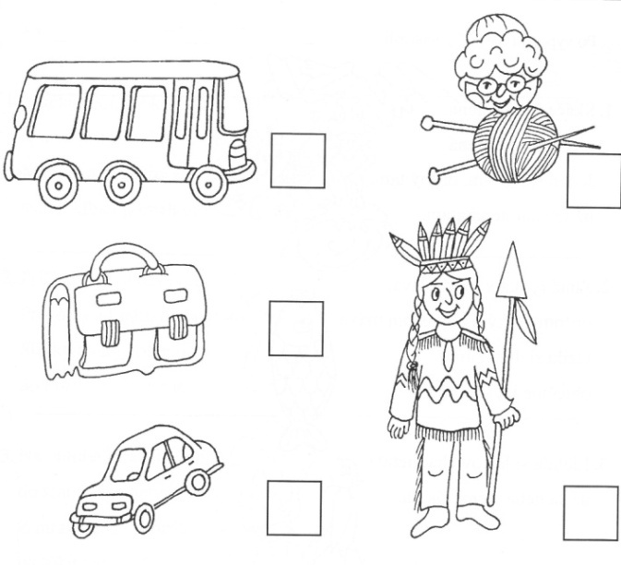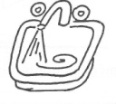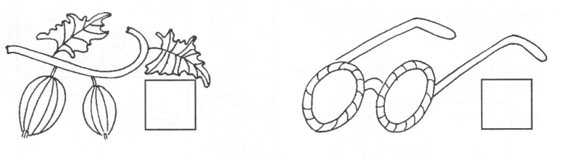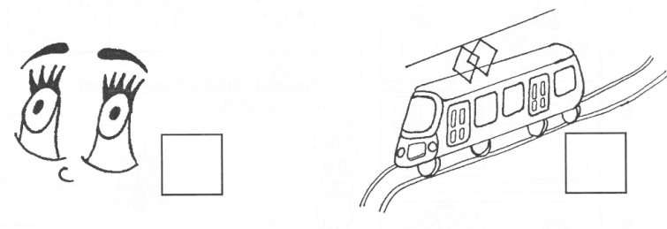**1. Napíš začiatočné písmeno.**

**2. Prepíš písmená.**

|  |  |  |  |  |  |  |  |  |  |  |  |
| --- | --- | --- | --- | --- | --- | --- | --- | --- | --- | --- | --- |
| m | A | i | u | ó | I | M | E | O | e | U | á |
|  |  |  |  |  |  |  |  |  |  |  |  |

**3. Napíš začiatočnú slabiku:**

|  |  |  |  |  |  |  |
| --- | --- | --- | --- | --- | --- | --- |
| C:\Users\ivo\Desktop\muchotrávka.jpg | C:\Users\ivo\Desktop\mesiac.jpg | C:\Users\ivo\Desktop\misa.jpg | C:\Users\ivo\Desktop\mača.jpg | C:\Users\ivo\Desktop\melón.jpg | C:\Users\ivo\Desktop\maco.jpg | C:\Users\ivo\Desktop\motýľ.jpg |
|  |  |  |  |  |  |  |