PL - ANJ - 4.B NUMBERS 1-30 - Čisla 1 až 30
1. Fill in the number! Doplň číslo do radu!
1. eleven, twelve, ........................... fourteen 6. twenty-one, ..........................., twenty-three, twenty-four
2. fifeen, ..........................., seventeen, eighteen 7. eighteen, .......................... twenty, .....................................
3. ten, ........................., twelve, thirteen 8. sixteen, ............................, eighteen, ...................................
4. twenty, nineteen, eighteen, ................................ 9. thirteen, ..........................., fifteen, .....................................
5. fourteen, thirteen, ..........................., eleven 10. twenty-nine, .................................., twenty – seven
2. Count!
1. ten + twenty = 6. twenty + seven = 11. twenty-four - eight =
2. eighteen + eleven = 7. fourteen + nine = 12. nineteen – seven =
3. fourteen + ten = 8. nineteen + three = 13. seventeen – eleven =
4. sixteen + five = 9. twelve + five = 14. thirty – twelve =
5. thirteen + six = 10. seven + eight = 15. twenty-six –thirteen =
3. Createthewords!
A | B | C | D | E | F | G | H | I | J | K | L | M
1 | 2 | 3 | 4 | 5 | 6 | 7 | 8 | 9 | 10 | 11 | 12 | 13
N | O | P | Q | R | S | T | U | V | W | X | Y | Z
14 | 15 | 16 | 17 | 18 | 19 | 20 | 21 | 22 | 23 | 24 | 25 | 26

seven | nine | eighteen | one | six | six | five
two | fifteen | fifteen | eleven

six | one | thirteen | nine | twelve | twenty-five
six | twelve | fifteen | twenty-three | five | eighteen
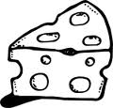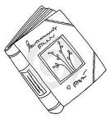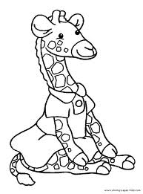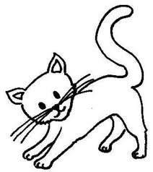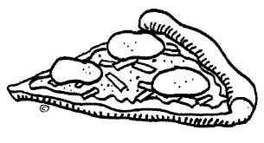

twenty-one | thirteen | two | eighteen | five | twelve | twelve | one
three | one | twenty
sixteen | nine | twenty-six | twenty-six | one

three | eight | five | five | nineteen | five

