1..

**Porozmýšľaj, čo sa deje na obrázkoch. Doplň a vypočítaj.**

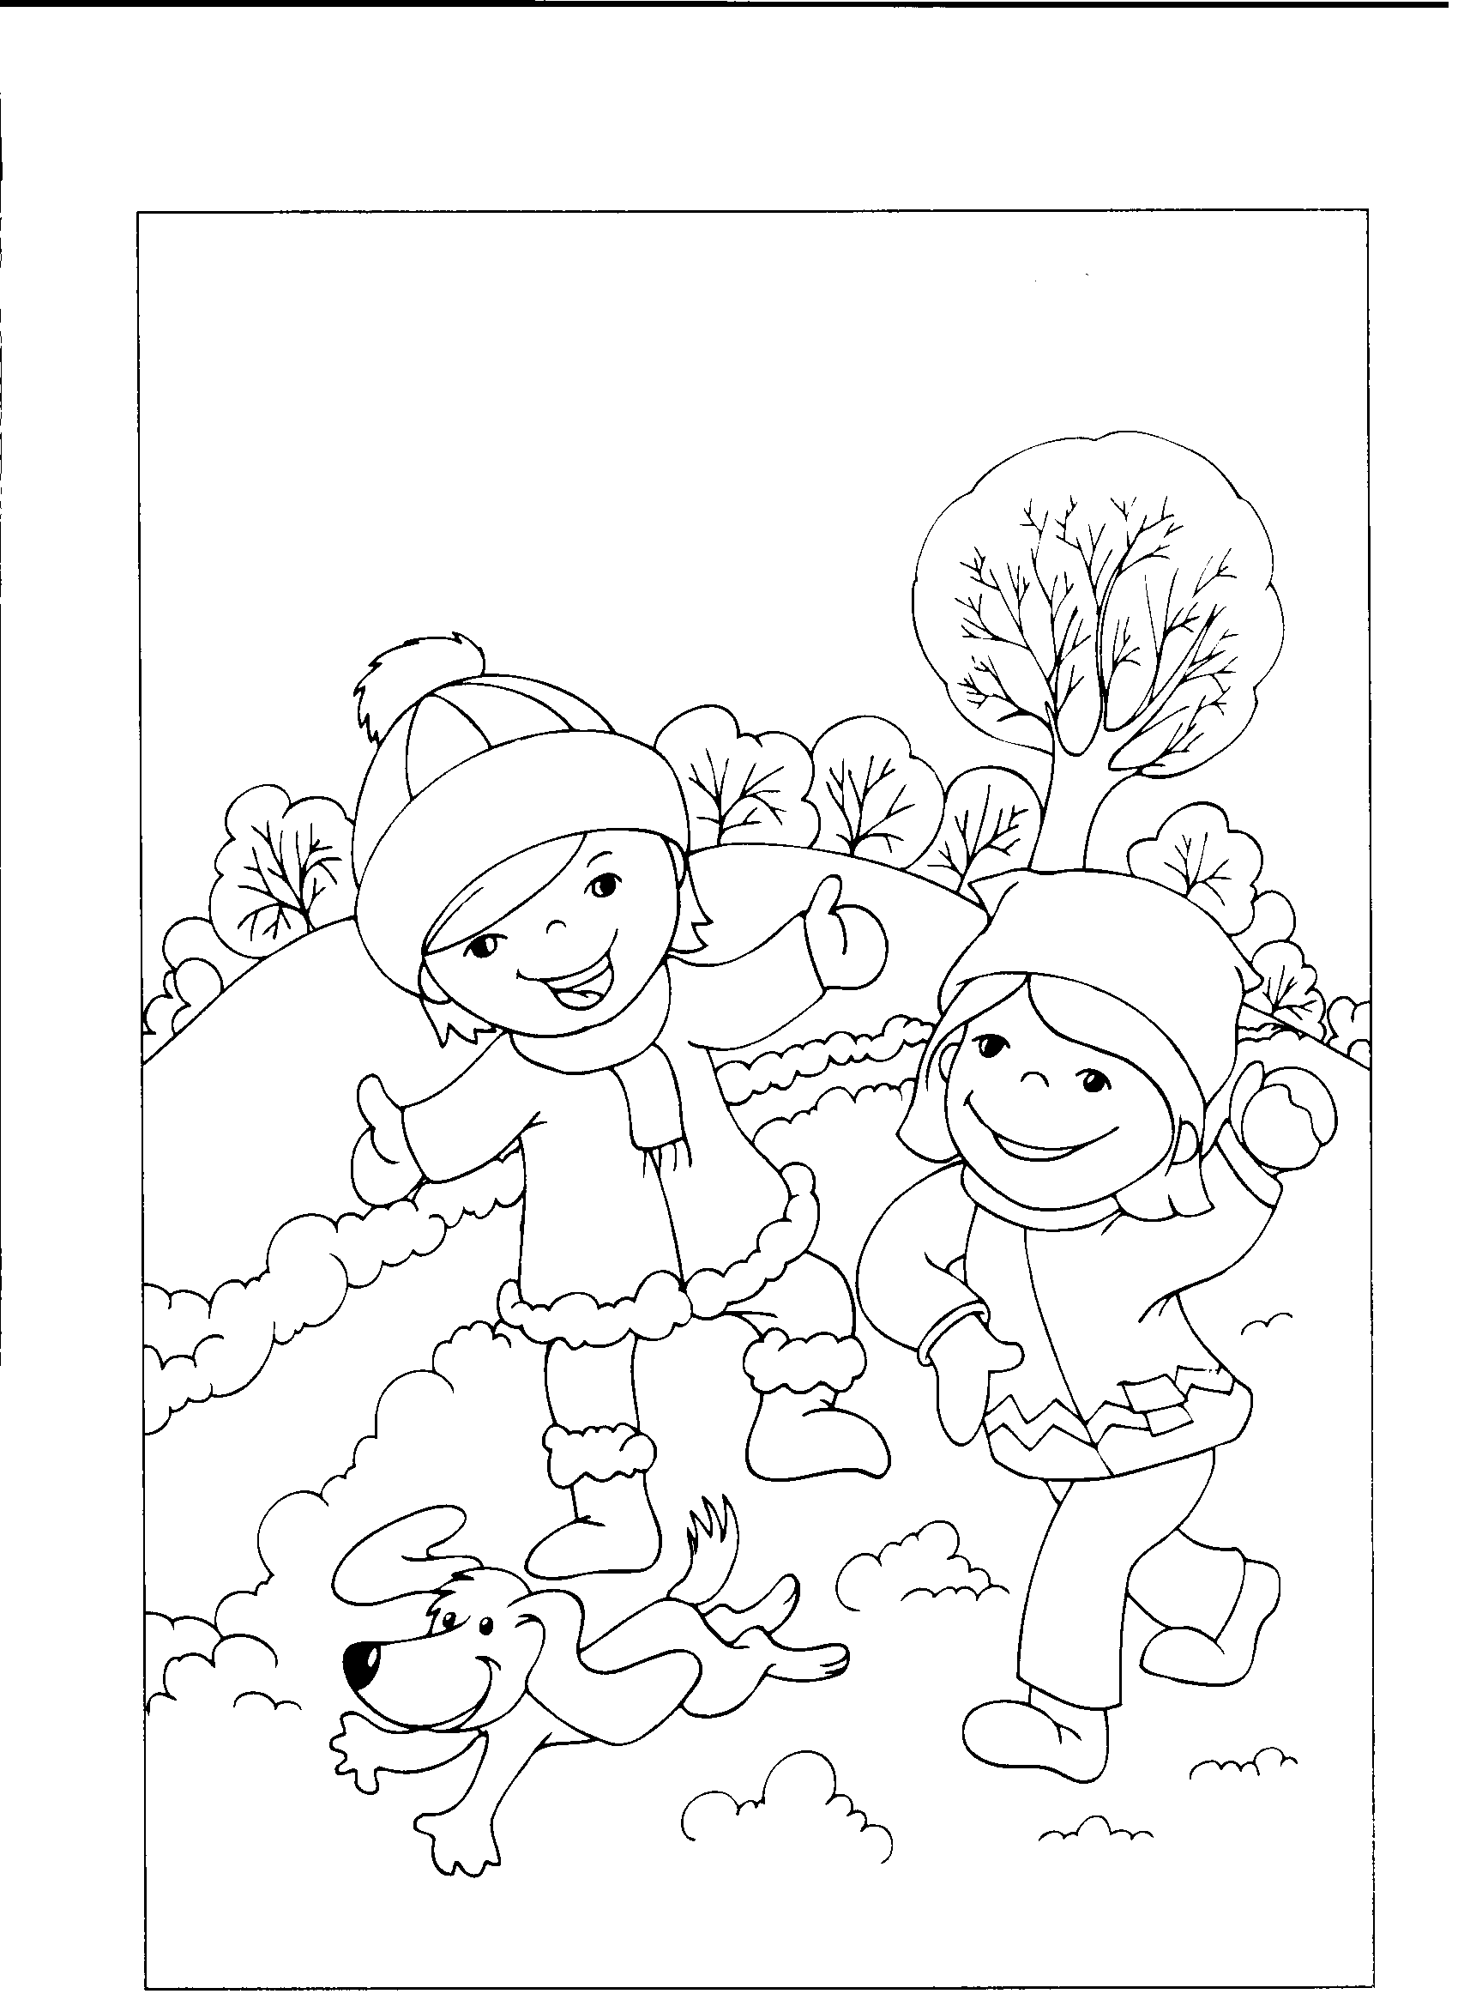

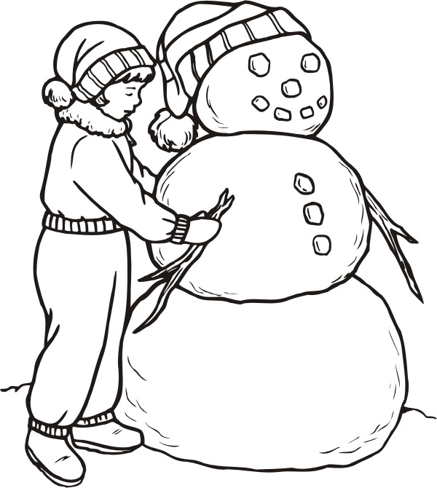

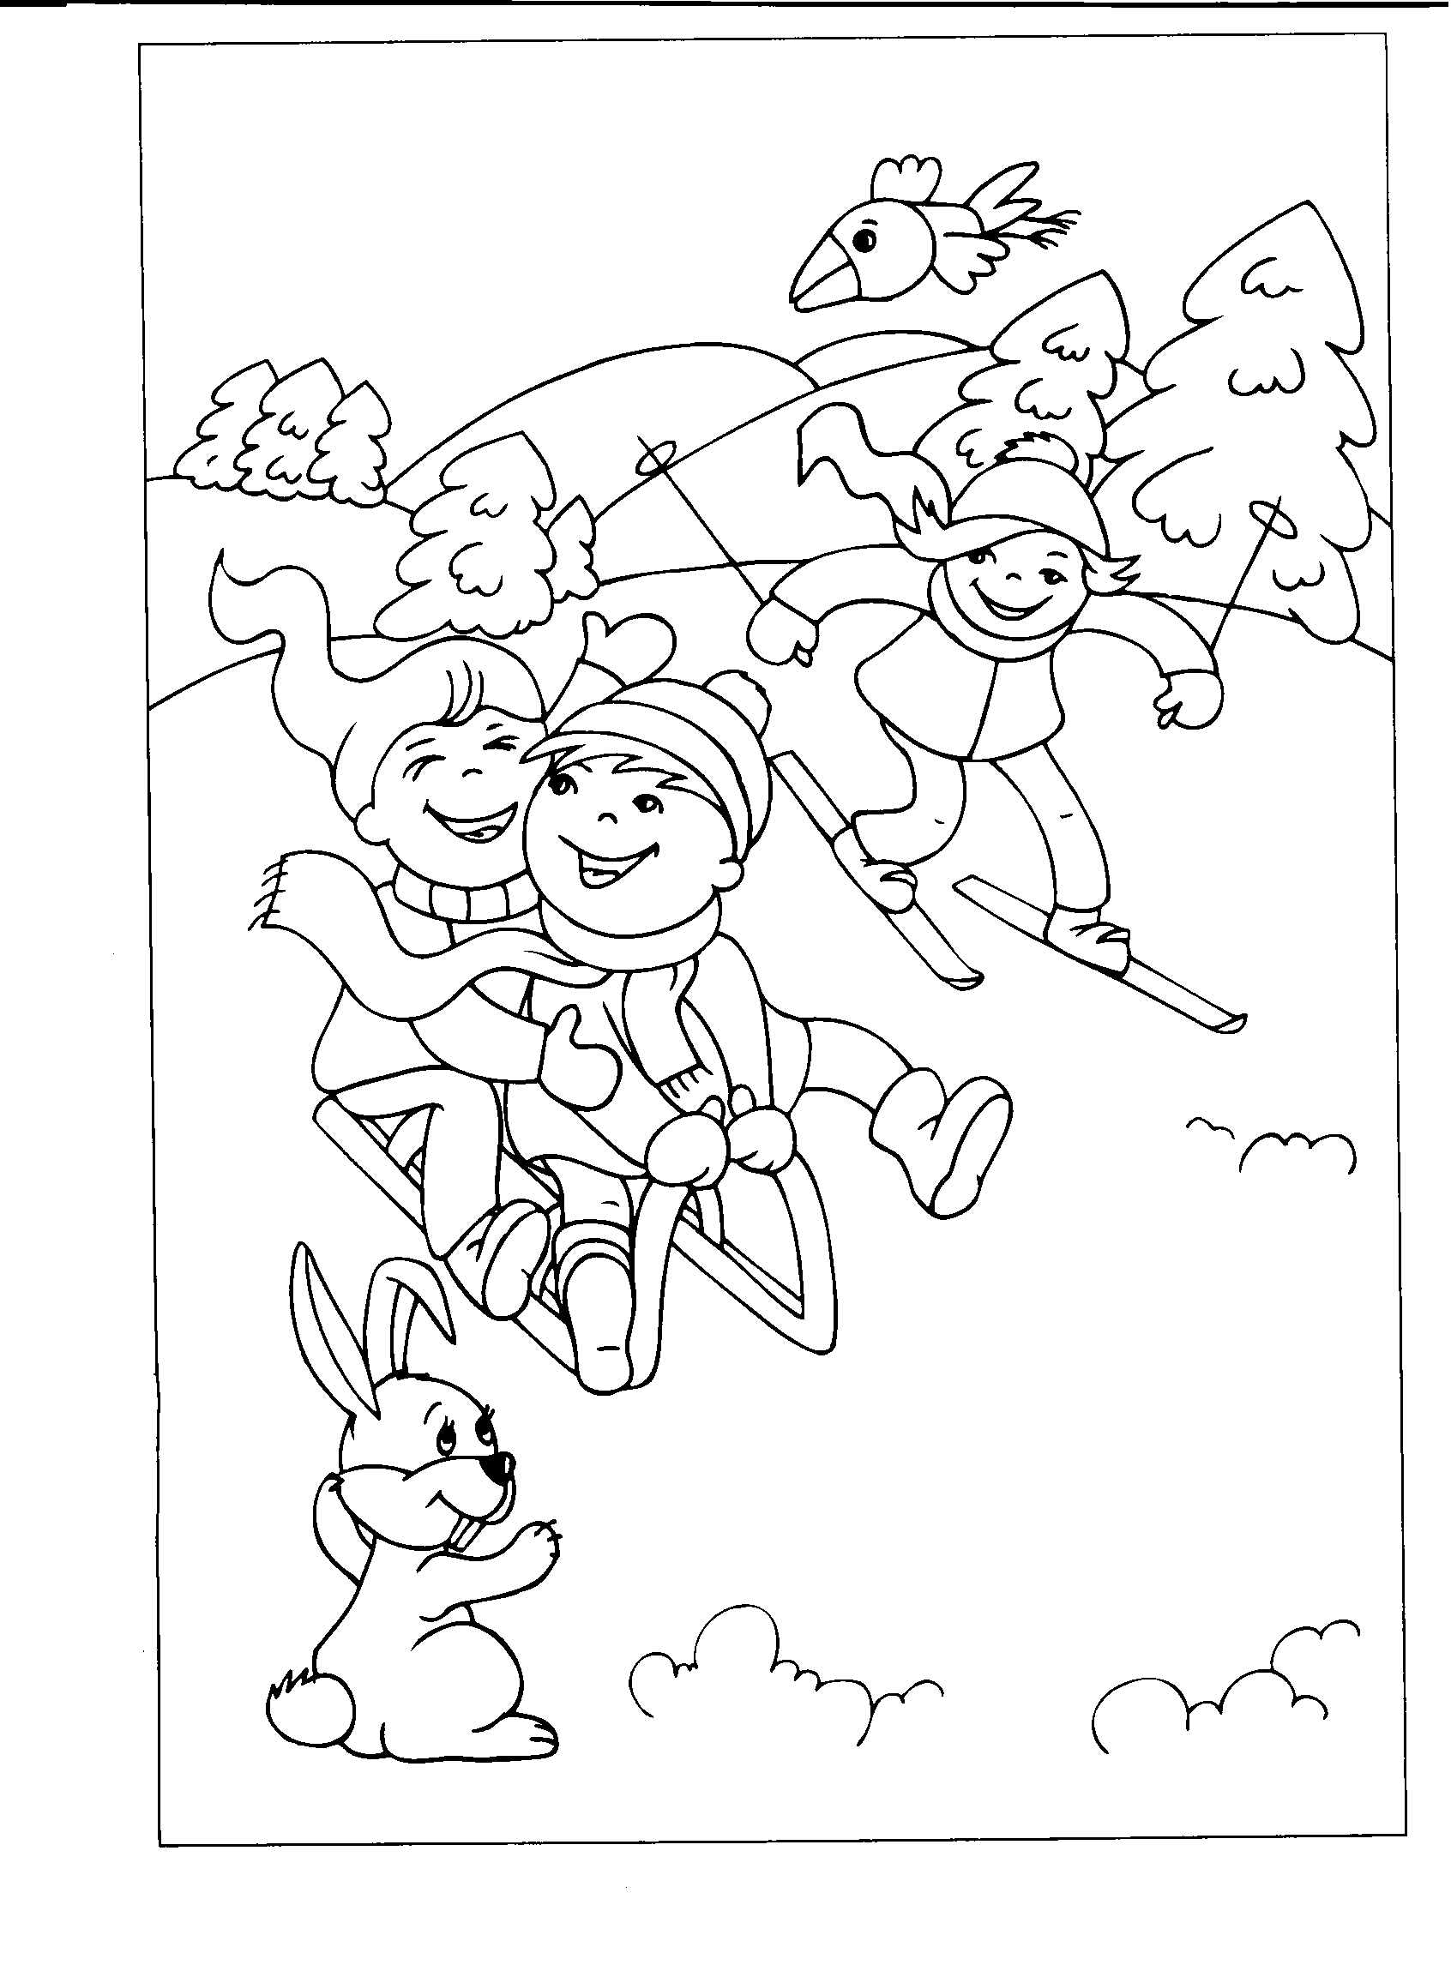





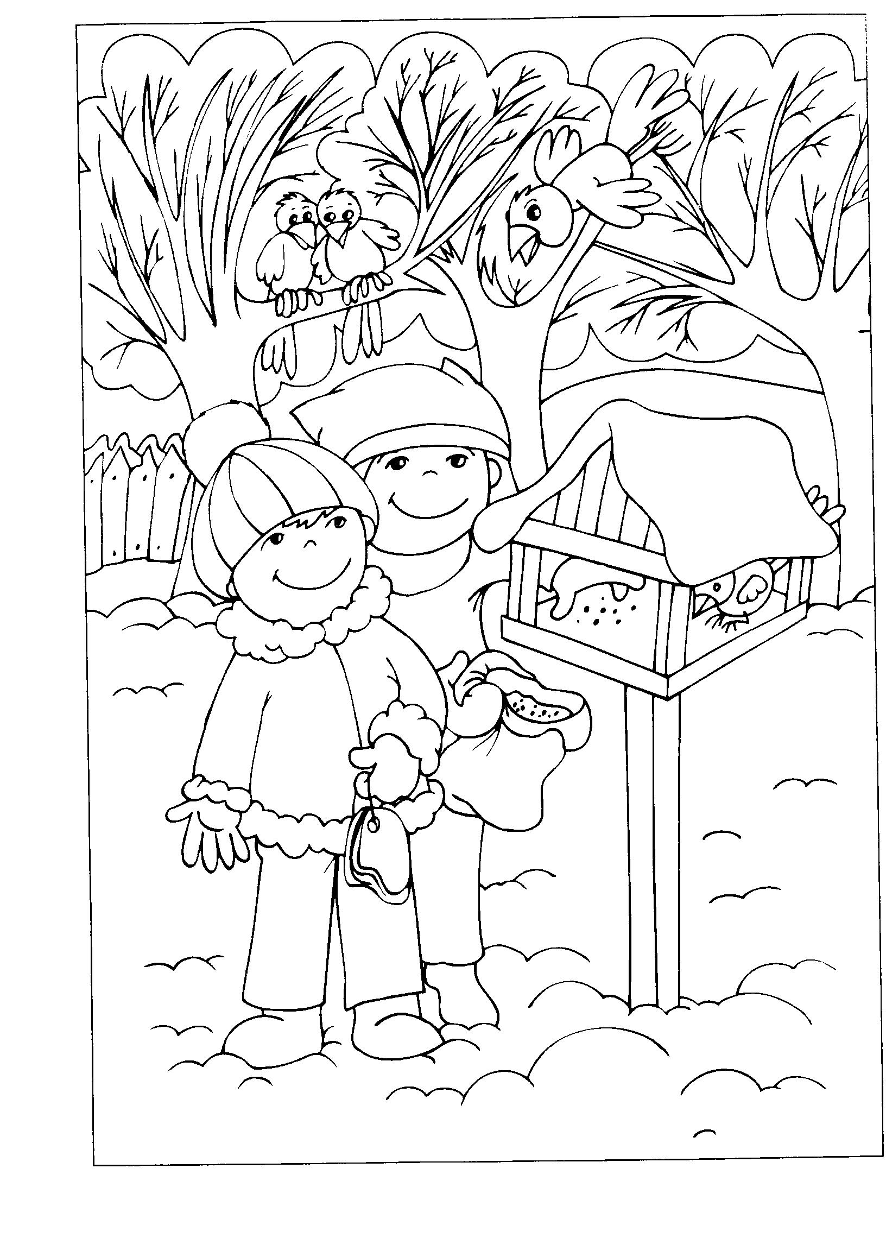

Bolo............... 6

Prišli............... 2

Spolu..............**?**

|  |  |  |  |  |
| --- | --- | --- | --- | --- |
|  | + |  | = |  |

Boli .................... 4

Prileteli ............... 3

Spolu.................... **?**

|  |  |  |  |  |
| --- | --- | --- | --- | --- |
|  | + |  | = |  |

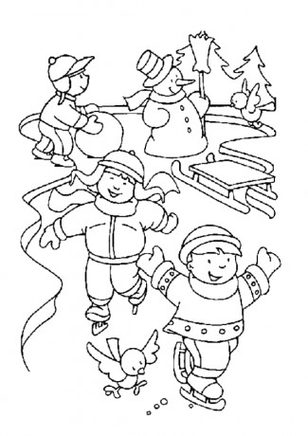

Bolo.................... 10

Odišlo................. 6

Zostalo ............... **?**

|  |  |  |  |  |
| --- | --- | --- | --- | --- |
|  | – |  | = |  |

Mal .......................7

Spadli mu............. 2

Zostalo ................. **?**

|  |  |  |  |  |
| --- | --- | --- | --- | --- |
|  | – |  | = |  |











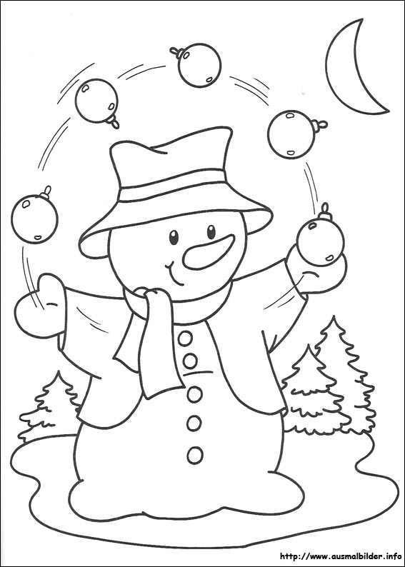

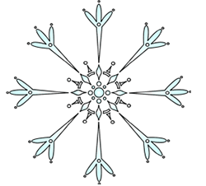



2..

**Doplň číselný rad.**

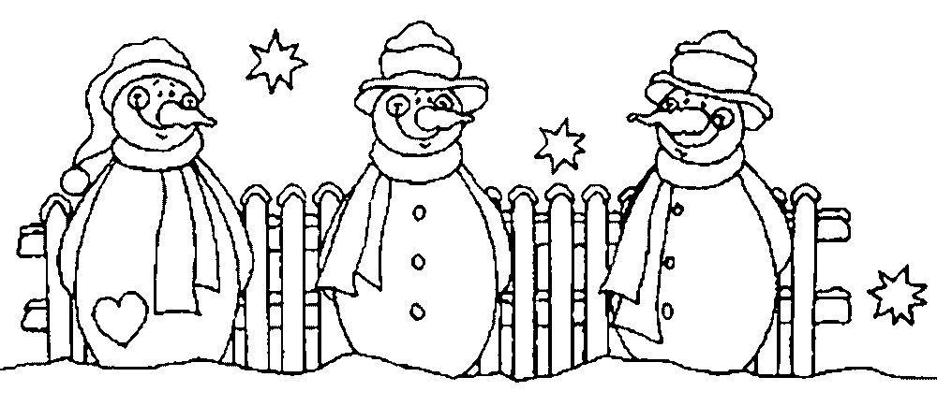



|  |  |  |  |  |  |  |  |  |  |  |  |  |  |  |  |  |  |  |
| --- | --- | --- | --- | --- | --- | --- | --- | --- | --- | --- | --- | --- | --- | --- | --- | --- | --- | --- |
|  |  | 2. |  |  |  |  |  |  |  | 6. |  | 7. |  |  |  |  |  |  |
|  |  |  |  |  |  |  |  |  |







3..

**Doplň chýbajúce čísla.**

|  |  |  |  |  |  |  |  |  |  |  |
| --- | --- | --- | --- | --- | --- | --- | --- | --- | --- | --- |
| 6 | + |  | = | 9 |  | 6 | + |  | = | 8 |
|  | | | | | | | | | | |
| 7 | + |  | = | 10 |  |  | + | 5 | = | 9 |
|  | | | | | | | | | | |
| 2 | + |  | = | 9 |  |  | + | 2 | = | 6 |
|  | | | | | | | | | | |

4..

**Doplň chýbajúce čísla.**



|  |  |  |  |  |  |  |  |  |  |  |
| --- | --- | --- | --- | --- | --- | --- | --- | --- | --- | --- |
| 10 | – |  | = | 4 |  |  | – | 3 | = | 1 |
|  | | | | | | | | | | |
| 8 | – |  | = | 6 |  |  | – | 4 | = | 3 |
|  | | | | | | | | | | |
| 5 | – |  | = | 2 |  |  | – | 2 | = | 5 |
|  | | | | | | | | | | |







5..

**Doplň rozklady:**

|  |  |  |  |  |  |  |  |  |  |  |  |  |  |  |  |
| --- | --- | --- | --- | --- | --- | --- | --- | --- | --- | --- | --- | --- | --- | --- | --- |
| 8 | | |  |  |  | 6 | | |  |  |  | 9 | | |  |
| 3 | |  |  | | 4 | |  |  | |  | |  | 3 | |



|  |  |  |  |  |  |  |  |  |  |  |  |  |  |  |  |
| --- | --- | --- | --- | --- | --- | --- | --- | --- | --- | --- | --- | --- | --- | --- | --- |
| 10 | | |  |  |  | 9 | | |  |  |  | 8 | | |  |
|  | |  | 2 | | 3 | |  |  | | 4 | |  |  | |

6..

**Vypočítaj:**



– 5

+2

+2

+1

+5

4

4

7..

**Vypočítaj nás:**

– 1

– 1

+5

– 4

– 5

– 4

+1

+6

+ 2

+ 1

+3 2

+3