**Živočíchy ktoré sa živia lovením sú dravce. Lovia korisť**

Mäsom[](https://www.google.sk/url?sa=i&rct=j&q=&esrc=s&source=images&cd=&ved=0ahUKEwj5gKPHvcvSAhXBBiwKHYeJB3IQjRwIBw&url=https://atlara.wordpress.com/page/118/&bvm=bv.149093890,d.bGg&psig=AFQjCNHd_WJoupS3D1hrIkx8Q7mImWK-xQ&ust=1489219519854893) Trávou[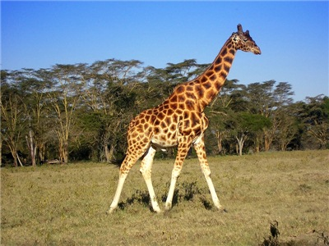](https://www.google.sk/url?sa=i&rct=j&q=&esrc=s&source=images&cd=&ved=0ahUKEwjHzsPYvcvSAhUhIJoKHfKADowQjRwIBw&url=http://server.sk/zaujimavosti/priroda/top-10-najvacsich-zijucich-zvierat-na-svete/&bvm=bv.149093890,d.bGg&psig=AFQjCNFcQVQbURKlREn-kJhgYTrwCbvJjA&ust=1489219653054227)

Semenami [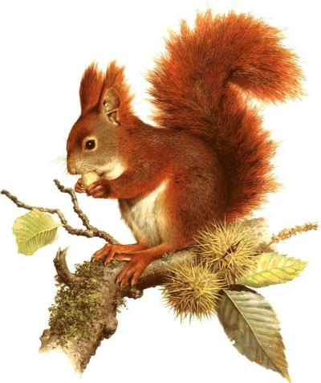](https://www.google.sk/url?sa=i&rct=j&q=&esrc=s&source=images&cd=&ved=0ahUKEwjYtZvkvcvSAhUIOJoKHTsYCyIQjRwIBw&url=http://snaturou2000.sk/zivocichy/veverica-stromova&bvm=bv.149093890,d.bGg&psig=AFQjCNFcQVQbURKlREn-kJhgYTrwCbvJjA&ust=1489219653054227)Hmyzom[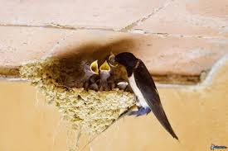](https://www.google.sk/url?sa=i&rct=j&q=&esrc=s&source=images&cd=&ved=0ahUKEwi0j7-IwcvSAhVLkCwKHewmBCAQjRwIBw&url=http://obrazky.4ever.sk/zvieratka/vtaky/lastovicky-232207&bvm=bv.149093890,d.bGg&psig=AFQjCNHFCWRPbOmwv1-PhaAXD7UpL_4xZQ&ust=1489220543484004)

**Potravinový reťazec**

[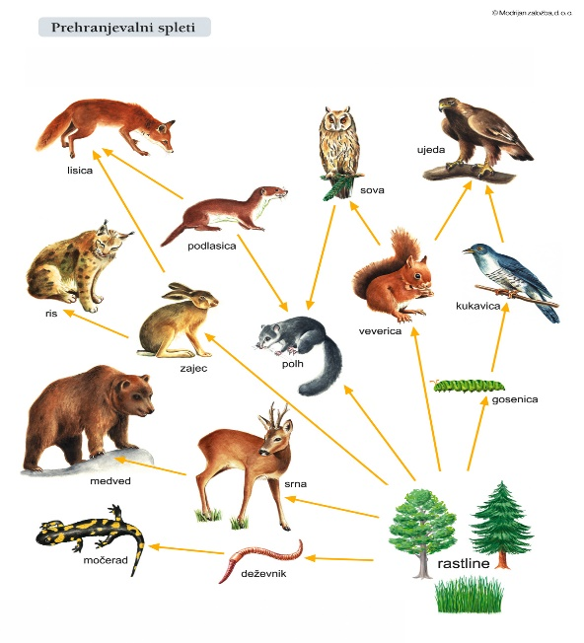](https://www.google.sk/url?sa=i&rct=j&q=&esrc=s&source=images&cd=&ved=0ahUKEwiY9ey8w8vSAhXjQZoKHZm7CmIQjRwIBw&url=http://narava7.blogspot.com/2013/04/prehranjevalni-splet.html&bvm=bv.149093890,d.bGg&psig=AFQjCNEqNgOGoUFNFkCbJyqvi-yd3TzURg&ust=1489220693464403)

[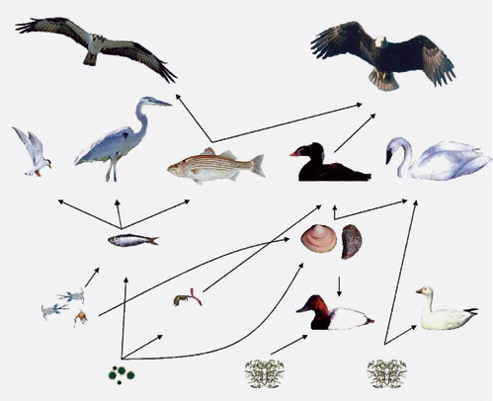](https://www.google.sk/url?sa=i&rct=j&q=&esrc=s&source=images&cd=&ved=0ahUKEwiJmufbwcvSAhWKNJoKHWrVAc8QjRwIBw&url=http://www.e-ucebnice.sk/e-ucebnice/biologia5naWelp/ekosystm_vd.html&bvm=bv.149093890,d.bGg&psig=AFQjCNEqNgOGoUFNFkCbJyqvi-yd3TzURg&ust=1489220693464403)

**Živočíchy sa dokážu maskovať vo svojom prostredí.**

[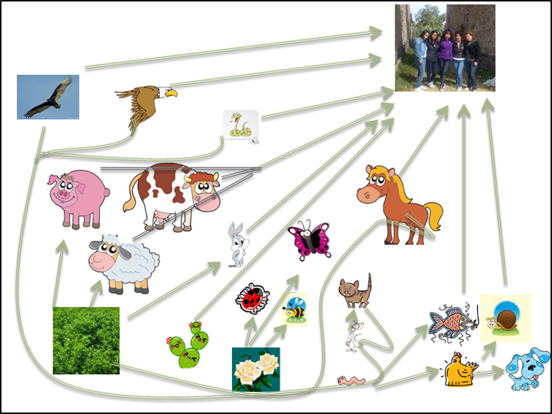](https://www.google.sk/url?sa=i&rct=j&q=&esrc=s&source=images&cd=&ved=0ahUKEwjIwJm0w8vSAhUIG5oKHQ3RBL8QjRwIBw&url=http://leoneldld.blogspot.com/2013_03_01_archive.html&bvm=bv.149093890,d.bGg&psig=AFQjCNEqNgOGoUFNFkCbJyqvi-yd3TzURg&ust=1489220693464403)