**Fruits and vegetables/** **Ovocie a zelenina** 3.D

Meno a priezvisko: .................................

|  |  |
| --- | --- |
| apple (epl) - jablko  banana (banana) - banán  carrot (kerot) - mrkva  cucumber (kjumbr) - uhorka  grape (grejp) - hrozno  orange (orindž) - pomaranč | pear (pír) - hruška  peas (pís) - hrach  pepper (pepr) - paprika  potato (potejto) - zemiak  strawberry (strobery) - jahoda  tomato (tumotej) - paradajka |

1. Priraď slová k obrázkom.

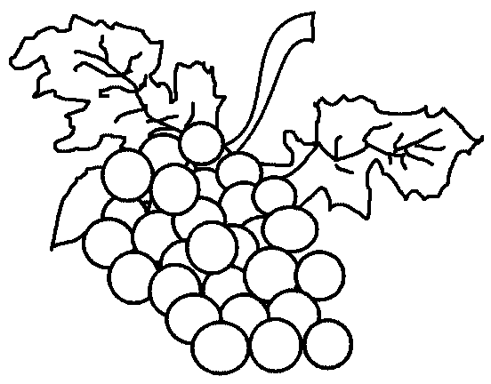 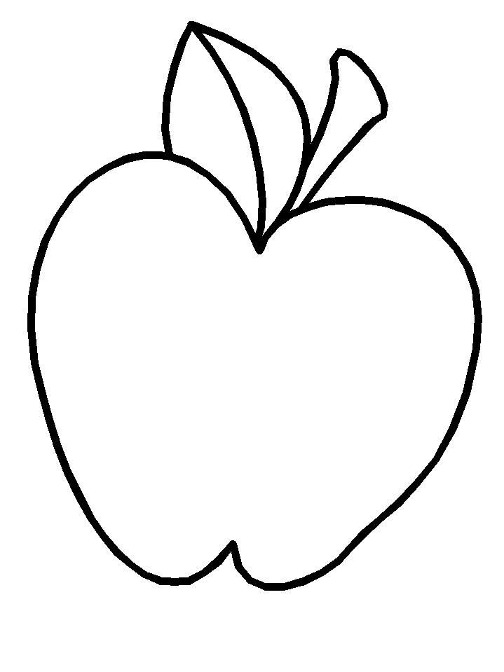 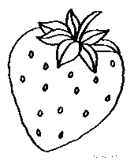 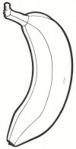 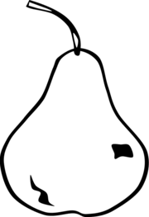 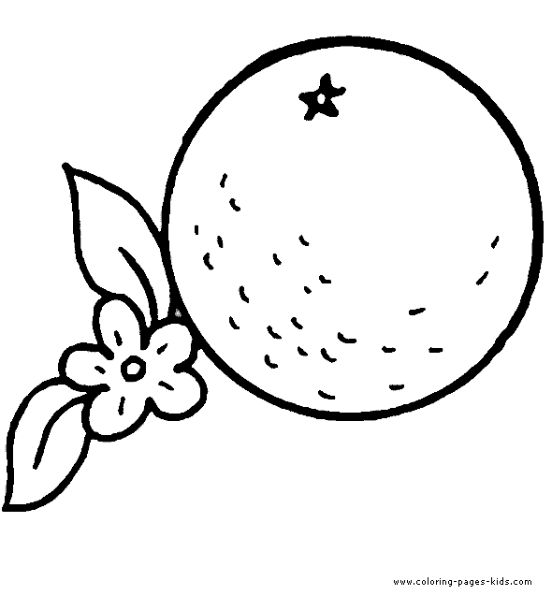

carrot banana peas apple

strawberry orange tomato pepper

grape potato cucumber pear

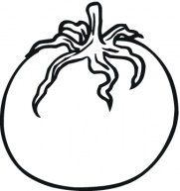 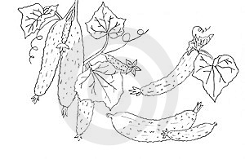 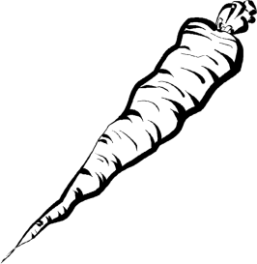 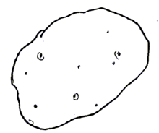 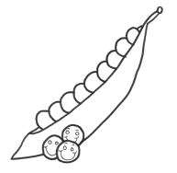 

2. Zakrúžkuj správnu odpoveď.

|  |  |
| --- | --- |
| V košíku je:  a) three bananas, two apples, two oranges, two pears  b) three oranges, two apples, one pear, two bananas  c) two pears, three oranges, three bananas, two apples | http://coloringbookfun.com/fruits/originalimages/fruit%20basket%2002.jpghttp://coloringbookfun.com/fruits/originalimages/fruit%20basket%2002.jpghttp://coloringbookfun.com/fruits/originalimages/fruit%20basket%2002.jpg |