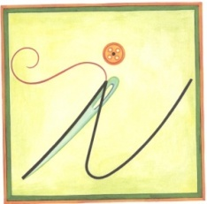 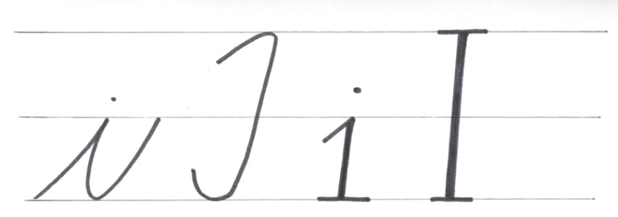

Pomenuj obrázky a vymaľuj tie obrázky, ktoré začínajú hláskou **i, I**.

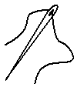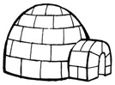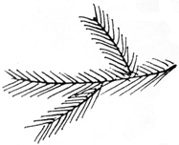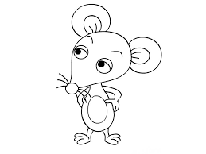 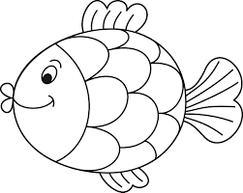 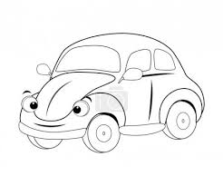

Vyhľadaj a vymaľuj v básni všetky písmená **i ,í, I, Í**.

|  |  |  |  |  |  |  |  |  |  |  |  |  |  |  |  |  |  |  |  |  |  |  |  |
| --- | --- | --- | --- | --- | --- | --- | --- | --- | --- | --- | --- | --- | --- | --- | --- | --- | --- | --- | --- | --- | --- | --- | --- |
| S | t | a | č | í, |  | a | b | y |  | i | h | l | a |  | u | h | l | a. |  |  |  |  |  |
| P | i | c | h | l | a |  | s | o | m |  | s | a, |  | a | h | a, |  | t | u | h | ľ | a! |  |
| Š | i | j | e | m, |  | š | i | j | e | m |  | n | o | h | a | v | i | č | k | y, |  |  |  |
| p | o | z | o | r |  | s | i |  | d | á | m |  | n | a |  | g | o | m | b | i | č | k | y. |
| I | h | l | a, |  | v | e | ď |  | m | i |  | r | o | v | n | o |  | n | i | ť, |  |  |  |
| p | o | t | o | m |  | b | u | d | e | m |  | p | e | k | n | e |  | š | i | ť. |  |  |  |