PL - SJL - 4. B **Číslo a rod podstatných mien**

Pomenuj čo alebo kto je na obrázku. Potom napíš slovo v pluráli (množnom čísle). Pomenuj čo alebo kto je na obrázku. Potom napíš rod.

|  |  |  |  |  |
| --- | --- | --- | --- | --- |
| O | P | I | C | A |

|  |  |  |  |
| --- | --- | --- | --- |
| D | L | A | Ň |

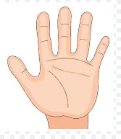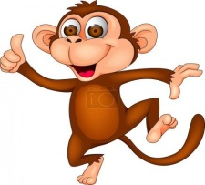

|  |  |  |  |  |
| --- | --- | --- | --- | --- |
| O | P | I | C | E |

**ženský rod**

**plurál**

|  |  |  |  |
| --- | --- | --- | --- |
|  |  |  |  |

|  |  |  |
| --- | --- | --- |
|  |  |  |

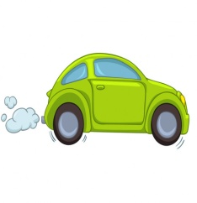

|  |  |  |  |
| --- | --- | --- | --- |
|  |  |  |  |

|  |  |  |  |  |
| --- | --- | --- | --- | --- |
|  |  |  |  |  |

|  |  |  |  |  |
| --- | --- | --- | --- | --- |
|  |  |  |  |  |

|  |  |  |  |  |
| --- | --- | --- | --- | --- |
|  |  |  |  |  |

|  |  |  |  |
| --- | --- | --- | --- |
|  |  |  |  |

|  |  |  |
| --- | --- | --- |
|  |  |  |

|  |  |  |  |  |  |
| --- | --- | --- | --- | --- | --- |
|  |  |  |  |  |  |

|  |  |  |
| --- | --- | --- |
|  |  |  |

|  |  |  |
| --- | --- | --- |
|  |  |  |

|  |  |  |
| --- | --- | --- |
|  |  |  |

|  |  |  |  |  |  |
| --- | --- | --- | --- | --- | --- |
|  |  |  |  |  |  |

|  |  |  |  |  |
| --- | --- | --- | --- | --- |
|  |  |  |  |  |

|  |  |  |  |
| --- | --- | --- | --- |
|  |  |  |  |

|  |  |  |  |
| --- | --- | --- | --- |
|  |  |  |  |

|  |  |  |  |  |
| --- | --- | --- | --- | --- |
|  |  |  |  |  |

|  |  |  |  |  |
| --- | --- | --- | --- | --- |
|  |  |  |  |  |

|  |  |  |  |  |
| --- | --- | --- | --- | --- |
|  |  |  |  |  |

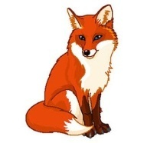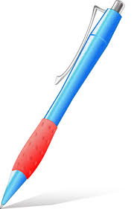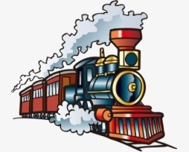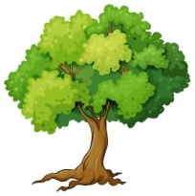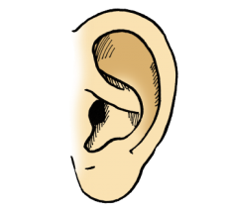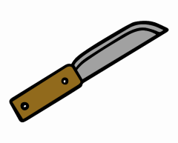

**plurál**

**plurál**

**plurál**

**plurál**

**plurál**

**plurál**

**plurál**