Poznáš čísla? Spočítaj ich a vymaľuj daný počet štvorčekov pod každým číslom.

 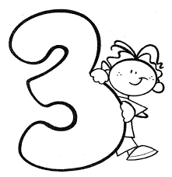     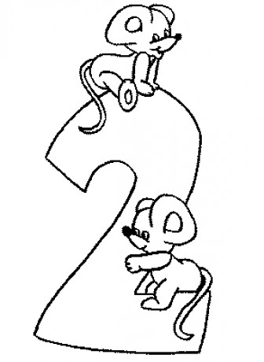      +

  

1 2 3 4 5

|  |  |  |  |  |  |  |  |  |  |
| --- | --- | --- | --- | --- | --- | --- | --- | --- | --- |
|  |  |  |  |  |  |  |  |  |  |
|  |  |  |  |  |  |  |  |  |  |
|  |  |  |  |  |  |  |  |  |  |
|  |  |  |  |  |  |  |  |  |  |
|  |  |  |  |  |  |  |  |  |  |