***1.PL- 25.1.2021- 0.A-*** SPÁJAŤ

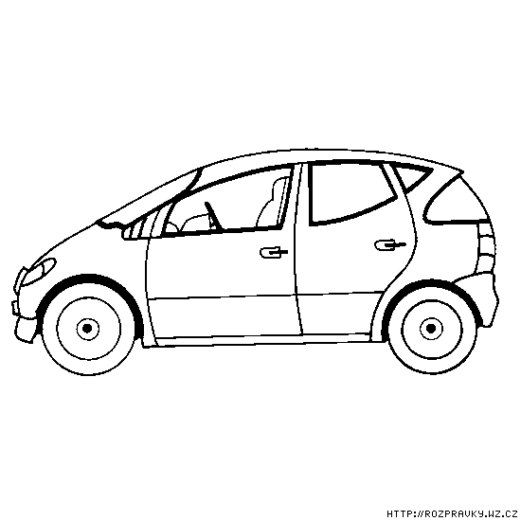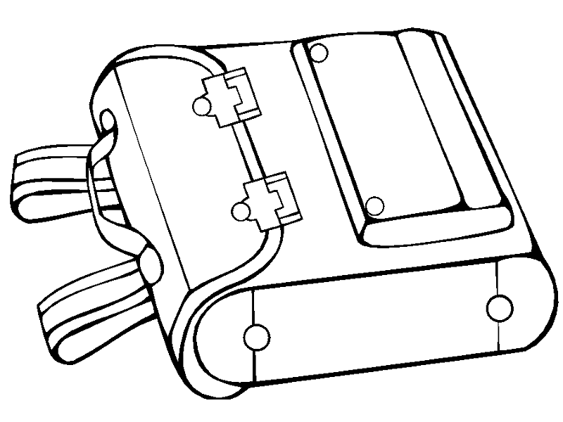

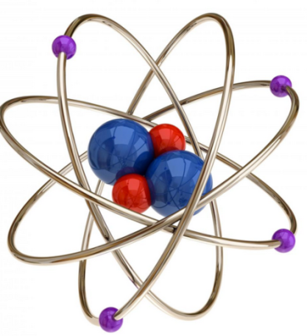

A

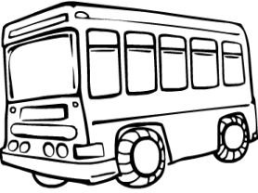

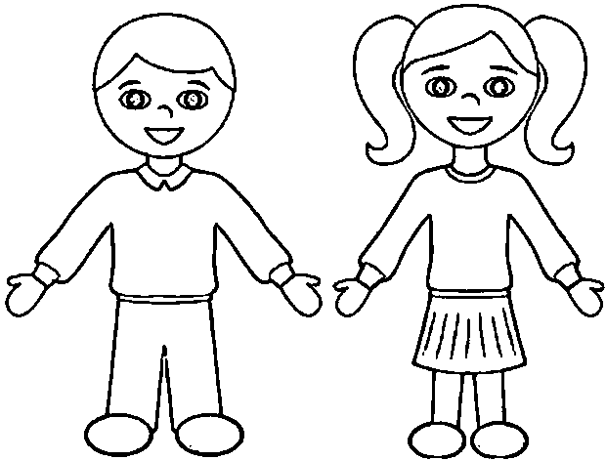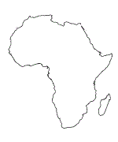

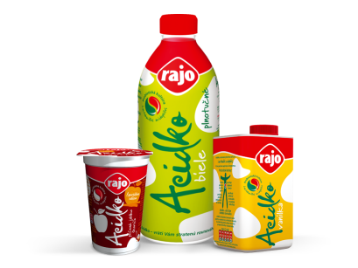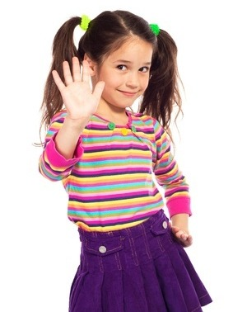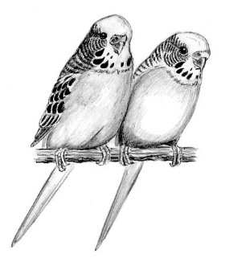

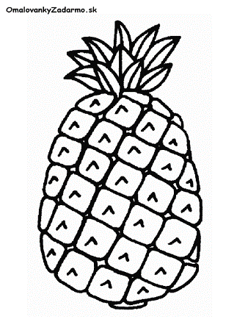

A

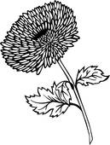

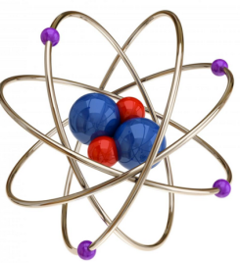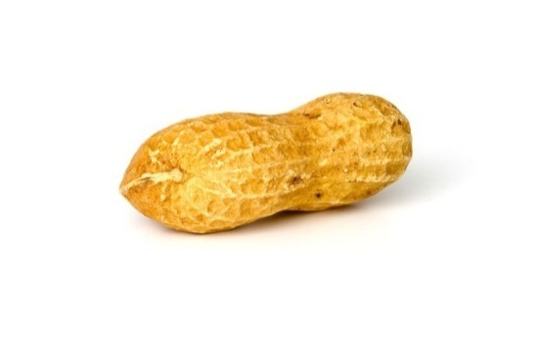

***2.PL- 25.1.2021- 0.A- SPÁJAŤ- ČO JE NA ZAČIATKU?***

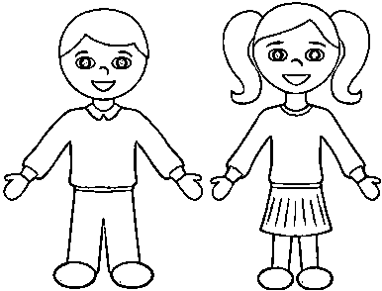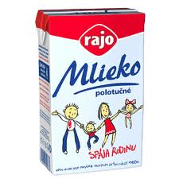

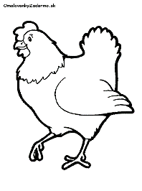

|  |  |  |  |  |
| --- | --- | --- | --- | --- |
|  |  |  |  |  |



|  |  |  |  |  |
| --- | --- | --- | --- | --- |
|  |  |  |  |  |

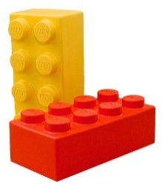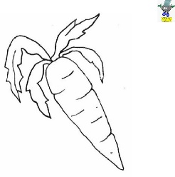

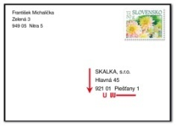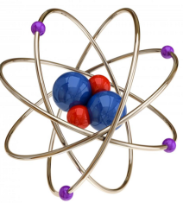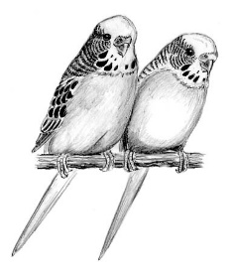

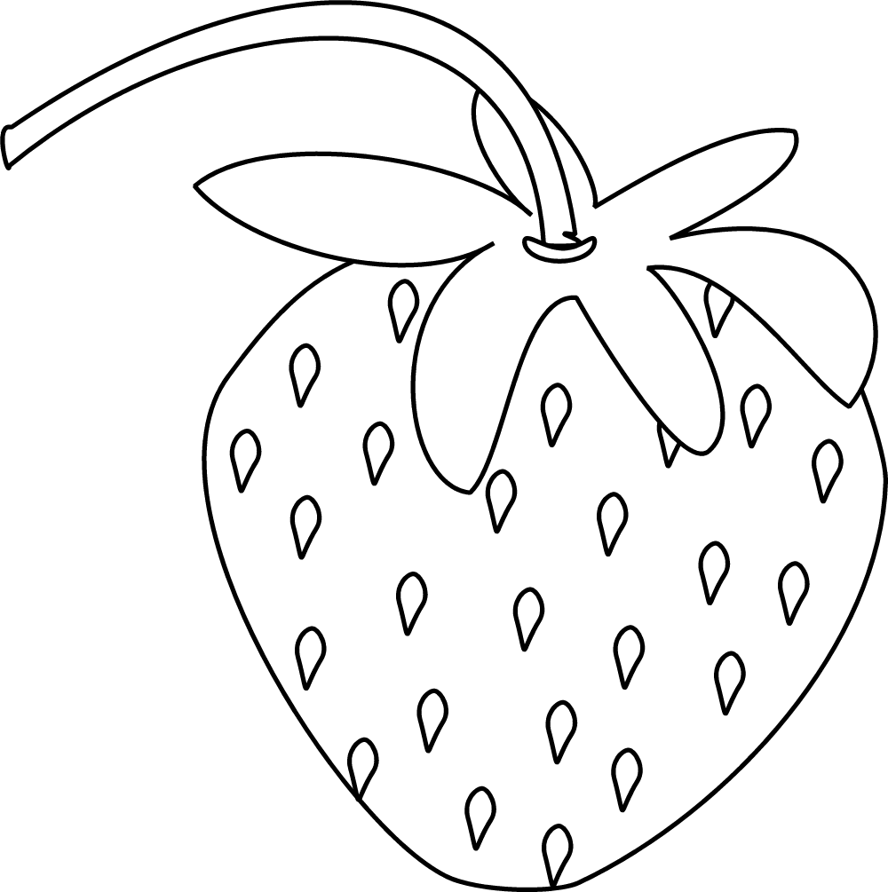 ***3.PL- 25.1.2021- 0.A- VYZNAČIŤ A***

|  |  |  |  |  |  |
| --- | --- | --- | --- | --- | --- |
| J | A | H | O | D | A |
| J |  | H | O | D |  |

|  |  |  |  |
| --- | --- | --- | --- |
| A | D | A | M |
|  | D |  | M |

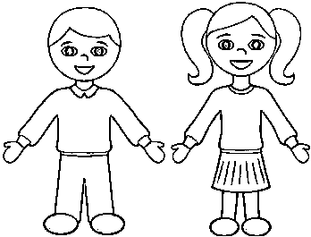

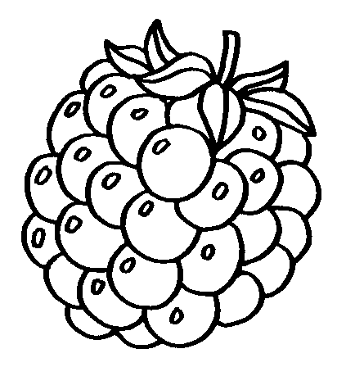

|  |  |  |  |  |  |
| --- | --- | --- | --- | --- | --- |
| M | A | L | I | N | A |
| M |  | L | I | N |  |

|  |  |  |  |  |
| --- | --- | --- | --- | --- |
| A | D | E | L | A |
|  | D | E | L |  |

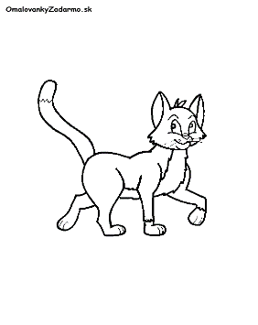

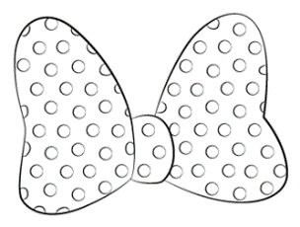

|  |  |  |  |  |
| --- | --- | --- | --- | --- |
| M | A | Č | K | A |
| M |  | Č | K |  |

|  |  |  |  |  |
| --- | --- | --- | --- | --- |
| M | A | Š | Ľ | A |
| M |  | Š | Ľ |  |

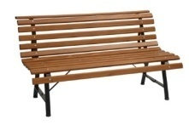

|  |  |  |  |  |  |  |
| --- | --- | --- | --- | --- | --- | --- |
| L |  | V | I | Č | K |  |