***1.PL- 25.1.2021- 0.A***

|  |  |  |  |  |  |
| --- | --- | --- | --- | --- | --- |
| 4 |  |  |  |  |  |
| 2 |  |  |  |  |  |
| 3 |  |  |  |  |  |
| 5 |  |  |  |  |  |
| 4 |  |  |  |  |  |

***2.PL- 25.1.2021- 0.A***

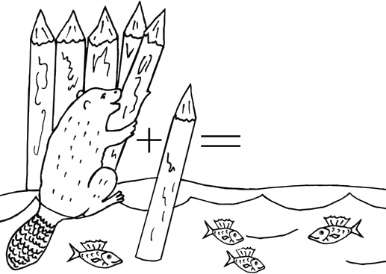

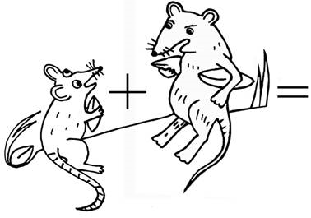

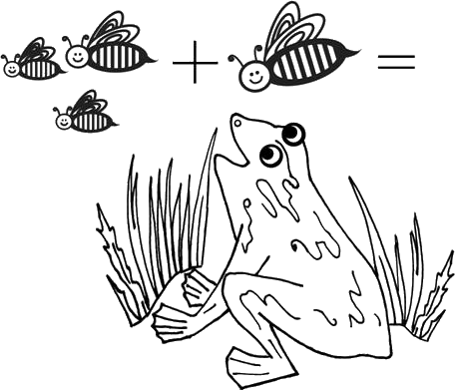

***3.PL- 25.1.2021- 0.A***

