1. **Pomenuj obrázky. Vymaľuj tie, ktoré sa začínajú na rovnakú hlásku.**

|  |  |  |  |  |
| --- | --- | --- | --- | --- |
|  |  |  |  |  |

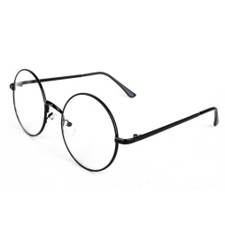

|  |  |  |  |  |
| --- | --- | --- | --- | --- |
|  |  |  |  |  |

|  |  |  |  |  |
| --- | --- | --- | --- | --- |
|  |  |  |  |  |

|  |  |  |  |  |
| --- | --- | --- | --- | --- |
|  |  |  |  |  |

|  |  |  |  |  |
| --- | --- | --- | --- | --- |
|  |  |  |  |  |

|  |  |  |  |  |
| --- | --- | --- | --- | --- |
|  |  |  |  |  |

1. **Pomenuj obrázky. Slabiku, ktorú počuješ na začiatku slova vyfarbi.**

|  |  |  |
| --- | --- | --- |
|  | | |
| **BA** | **MA** | **LE** |

|  |  |  |
| --- | --- | --- |
|  | | |
| **MA** | **VE** | **TO** |

|  |  |  |
| --- | --- | --- |
|  | | |
| **SO** | **LU** | **SO** |

|  |  |  |
| --- | --- | --- |
|  | | |
| **MI** | **LA** | **CA** |

|  |  |  |
| --- | --- | --- |
|  | | |
| **MU** | **NO** | **JA** |