ANGLICKÝ JAZYK pre 3. Ročník Oklamčaková Jana

1. Spoj obrázok s vhodným slovom
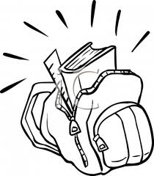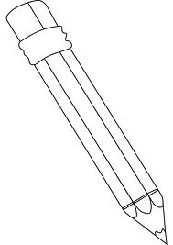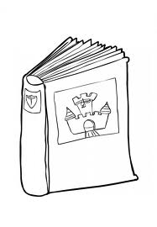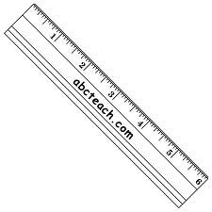

pencil books ruler school bags

rubbers pen colouring pencils pencil case

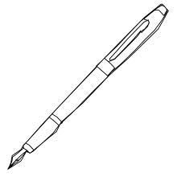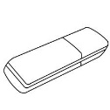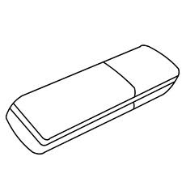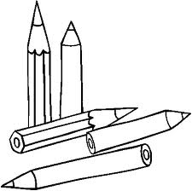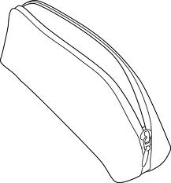

2.Uprav vety do správneho tvaru a dopíš: Yes, I have. No, I haven´t.

a ball? Have got you 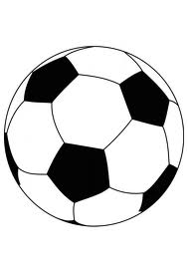 __________________________________________

_______________________
you got Have a bike? 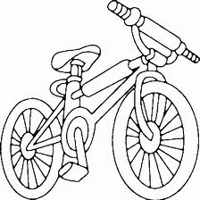 __________________________________________

________________________
Have you a skateboard got? 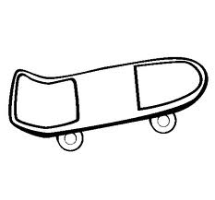________________________________________

________________________

got Have you a scooter?  



