PL - ANJ - 4.B

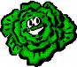
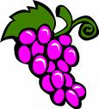
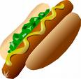
1. What′s this? Pomenuj.

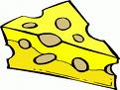
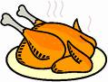
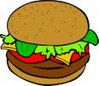
____________ ____________ ___________ ___________ ____________
__________ ____________ ___________ ____________ ____________

Pomôcka: /Grapes, Lettuce, Egg, Salami, Hot dog,.... Ice cream, Hamburger, Cake, Cheese, Chicken/

2. What′s this ? / Prelož, čo znamená:

Fish................................... Ham and eggs.................................
Pizza................................. Chips .............................................
Sausage ............................ Butter.............................................

3. Match the correct sentence. Priraď správne vety.

Can I have chips? Ja som hladný.
I am hungry. Môžem dostať hranolky?
What do you want to drink? Čo máš rád?
You are welcome. Nech sa páči.
What do you like? Čo chceš piť?
Here you are. Rado sa stalo.

