HAPPY BRITHDAY/ Šťastné narodeniny 3.D
Meno a priezvisko: ..................................................
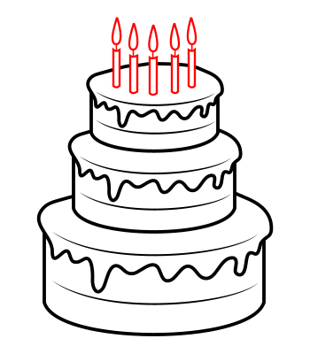  CAKE | PRESENT | 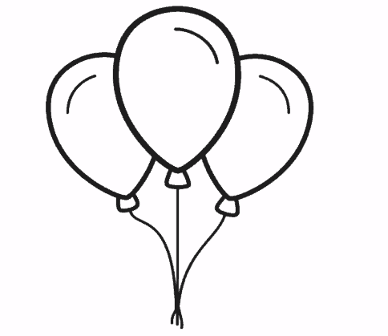  BALLOONS

How old are you? I m .
Draw and colour your brithday cake. (Nakresli a vyfarbi svoju narodeninovú tortu)

