***1.PL-1.2.2021- 0.A-*** SPÁJAŤ

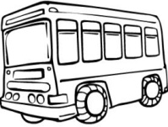

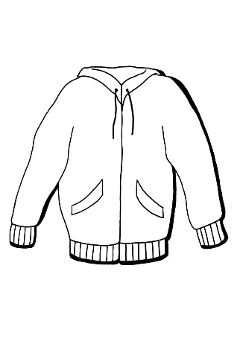

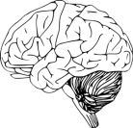

M

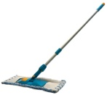

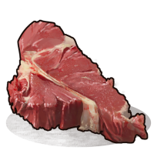

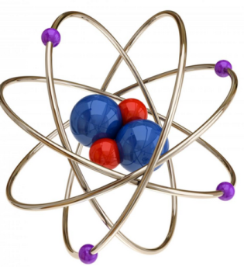

A

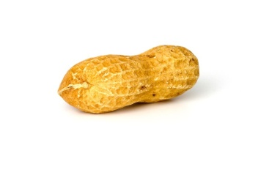

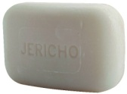

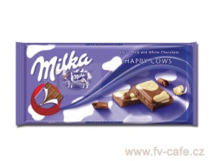



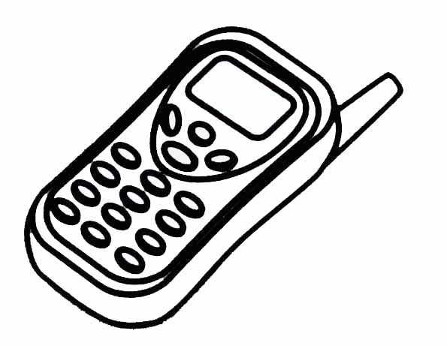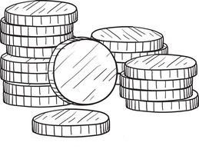

ČÍTA

***2.PL- 1.2.2021- 0.A-* ČÍTAŤ A VYZNAČIŤ-- A, M**

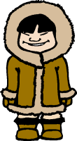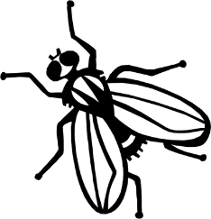

|  |  |  |  |  |  |  |
| --- | --- | --- | --- | --- | --- | --- |
| E | S | K | Y | M | Á | K |
| E | S | K | Y |  |  | K |

|  |  |  |  |
| --- | --- | --- | --- |
| M | U | CH | A |
|  | U | CH |  |

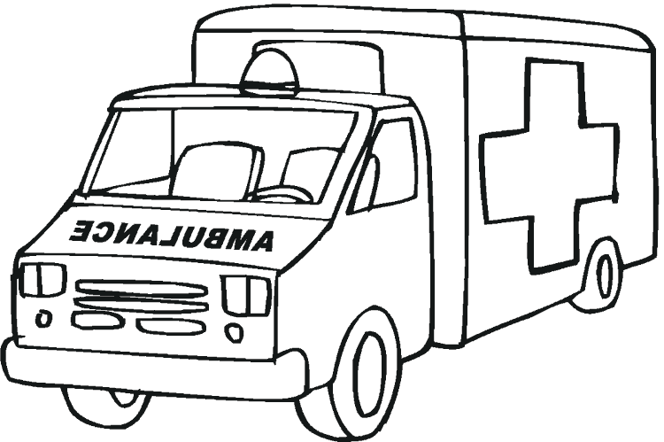

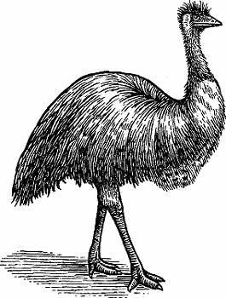

|  |  |  |  |  |  |  |  |  |
| --- | --- | --- | --- | --- | --- | --- | --- | --- |
| A | M | B | U | L | A | N | C | IA |
|  |  | B | U | L |  | N | C | IA |

|  |  |  |
| --- | --- | --- |
| E | M | U |
| E |  | lopata2U |

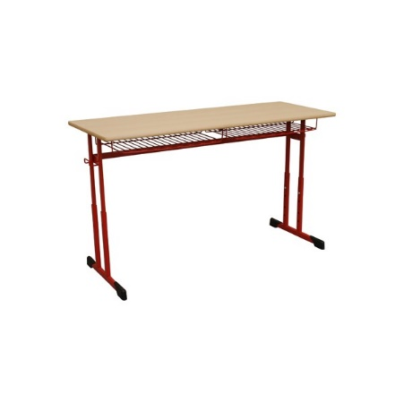

|  |  |  |  |  |  |
| --- | --- | --- | --- | --- | --- |
| L | O | P | A | T | A |
| L | O | P |  | T |  |

|  |  |  |  |  |  |
| --- | --- | --- | --- | --- | --- |
| L | A | V | I | C | A |
| L |  | V | I | C |  |

***3.PL- 1.2..2021- 0.A-*** PÍSAŤ

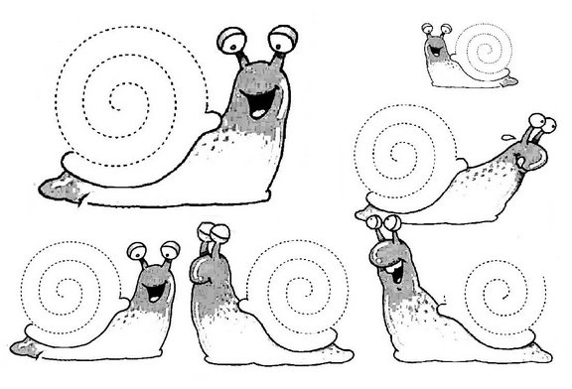

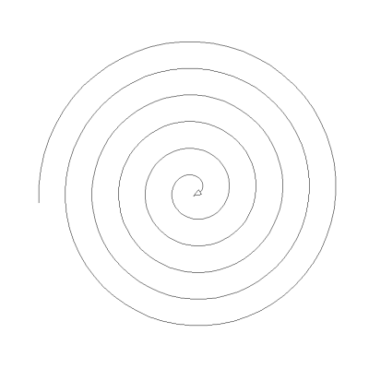

***4.PL- 1.2.2021- 0.A-* ČO JE NA ZAČIATKU?**



          
          
          