RGM - 0. ročník – moje prvé čiary
Meno: ........................................
- Doplň do riadka podľa predlohy, šarkana vyfarbi:
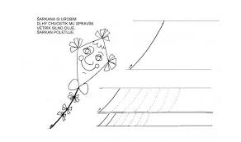
- Skús sám písať čiary podľa obrázka:

________________________________________________________________________________________________________________________________________________________________________________________________________________________________________________________________________________________________________________________________________________________________________________________________________________________________________________________________________________________________________________________________________________________________________________________________________________________________________________________________________________

