**1.PL- 11.1.2021- 0.A**

**Spočítaj geometrické útvary**

[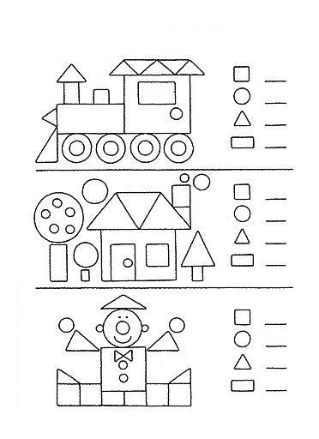](http://www.anasinifim.net/showthread.php?t=1629&s=636884185b377fbdb768a98730837898)

**2.PL- 11.1.2021- 0.A**

Počítame, dopĺňame a vyfarbujeme

Spočítaj a zapíš počet obrázkov.

|  |  |  |  |  |  |
| --- | --- | --- | --- | --- | --- |
|  |  |  |  |  |  |
|  |  |  |  |  |  |
|  |  |  |  |  |  |
|  |  |  |  |  |  |
|  |  |  |  |  |  |

**3.PL- 11.1.2021- 0.A**

Dokresli chýbajúce obrázky.



|  |  |  |  |  |  |
| --- | --- | --- | --- | --- | --- |
| 3 |  |  |  |  |  |
| 4 |  |  |  |  |  |
| 5 |  |  |  |  |  |
| 2 |  |  |  |  |  |
| 1 |  |  |  |  |  |