Name & Class: ......................................... NUMBERS

1 – one (van)
2 – two (tu)
3 – three (ϴri)
4 – four (fó)
5 – five (faiv)
6 – six (six)
7 – seven (sevn)
8 – eight (ejt)
9 – nine (najn)
10 – ten (ten)
11 - eleven [i´levn]
12 - twelve [twelv]
13 - thirteen [ θə:´ti:n]
14 - fourteen [fo:ti:n]
15 - fifteen [fif´ti:n]
16 - sixteen [,sik´sti:n]
17 - seventeen [,sevn´ti:n]
18 - eighteen [ei´ti:n]
19 - nineteen [,nain´ti:n]
20 - twenty [´twenti ]

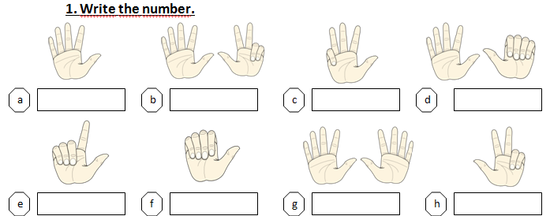

2. Complete with numbers.

Twelve + five = 17 | Sixteen + two =
Ten + ten = | Eighteen + one =
Three + eleven = | Four + fifteen =

3. Count and write.

_____sixteen______
________________
________________
________________
________________
________________

