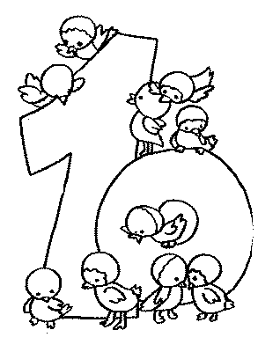

|  |  |  |  |  |  |  |  |
| --- | --- | --- | --- | --- | --- | --- | --- |
| 10 | 10 | 10 | 10 | 10 |  |  |  |
| 10 |  |  |  |  |  |  |  |
| 10 |  |  |  |  |  |  |  |
| 10 |  |  |  |  |  |  |  |
| 10 |  |  |  |  |  |  |  |
| 10 |  |  |  |  |  |  |  |
| 10 |  |  |  |  |  |  |  |
| 10 8 6 |  |  |  |  |  |  |  |

|  |  |  |  |  |  |  |  |
| --- | --- | --- | --- | --- | --- | --- | --- |
|  |  |  |  |  |  |  |  |
|  |  |  |  |  |  |  |  |