PL _ ANJ -4.B Predložky on (na), in (v), under (pod).
on - /na/

The monkey is on the box.

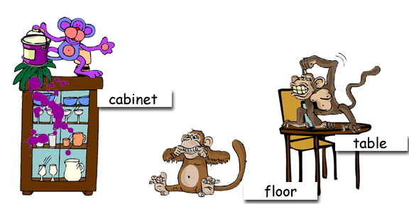

Where are the monkeys?

------------------------------------------------
The monkey is on
.........................................................................................................................
The monkey is
.........................................................................................................................
The monkey
.......................................................................................................
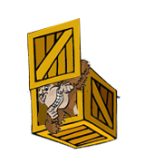 | In -/ V/  The monkey is in the box.

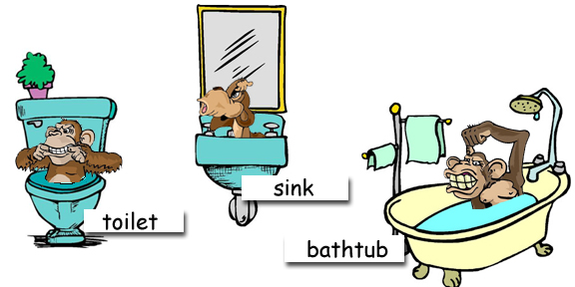

Where are the monkeys?
---------------------------------------------------------------------------------------------------------------------
The monkey is in ...................................................................................................
The monkey is .......................................................................................................
The monkey ............................................................................................................

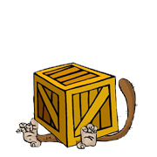 | Under - /pod/  The monkey is under the box.
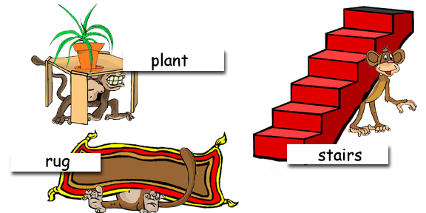

Where are the monkeys?
---------------------------------------------------------------------------------------------------------------------------------
The monkey is under ...........................................................................
The monkey ...........................................................................................
The monkey .............................................................................................

