PL - ANJ - 4.B Zvieratá – Animals

|  |
| --- |
| farm1 |
| ftxtfarm |

|  |  |  |  |
| --- | --- | --- | --- |
|  | |  |  |
| 2dog | 2duck | 2horse | 2goat |
| 2pig | 2rabbit | 2sheep | 2turkey |
| 2chickens | 2hen | 2rooster | 2chicks |

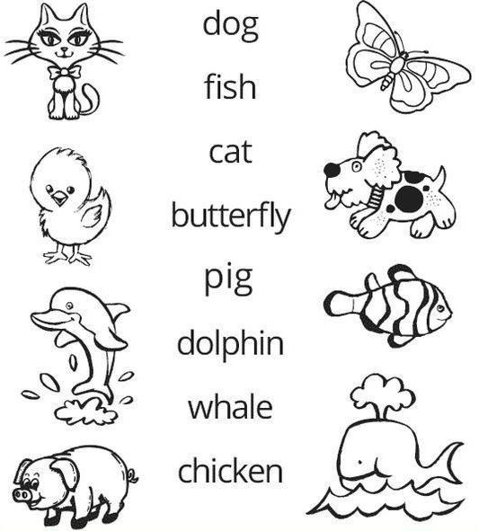

**Úloha:**  Spoj čiarami názvy zvierat s obrázkami. Čo k čomu patrí.