FAMILY- RODINA 3.D
Meno a priezvisko: ........................................

POJEM
Here’s the father, here’s the mother.
Here’s the sister, here’s the brother.
Father, mother, sister, brother,
hand in hand with one another.
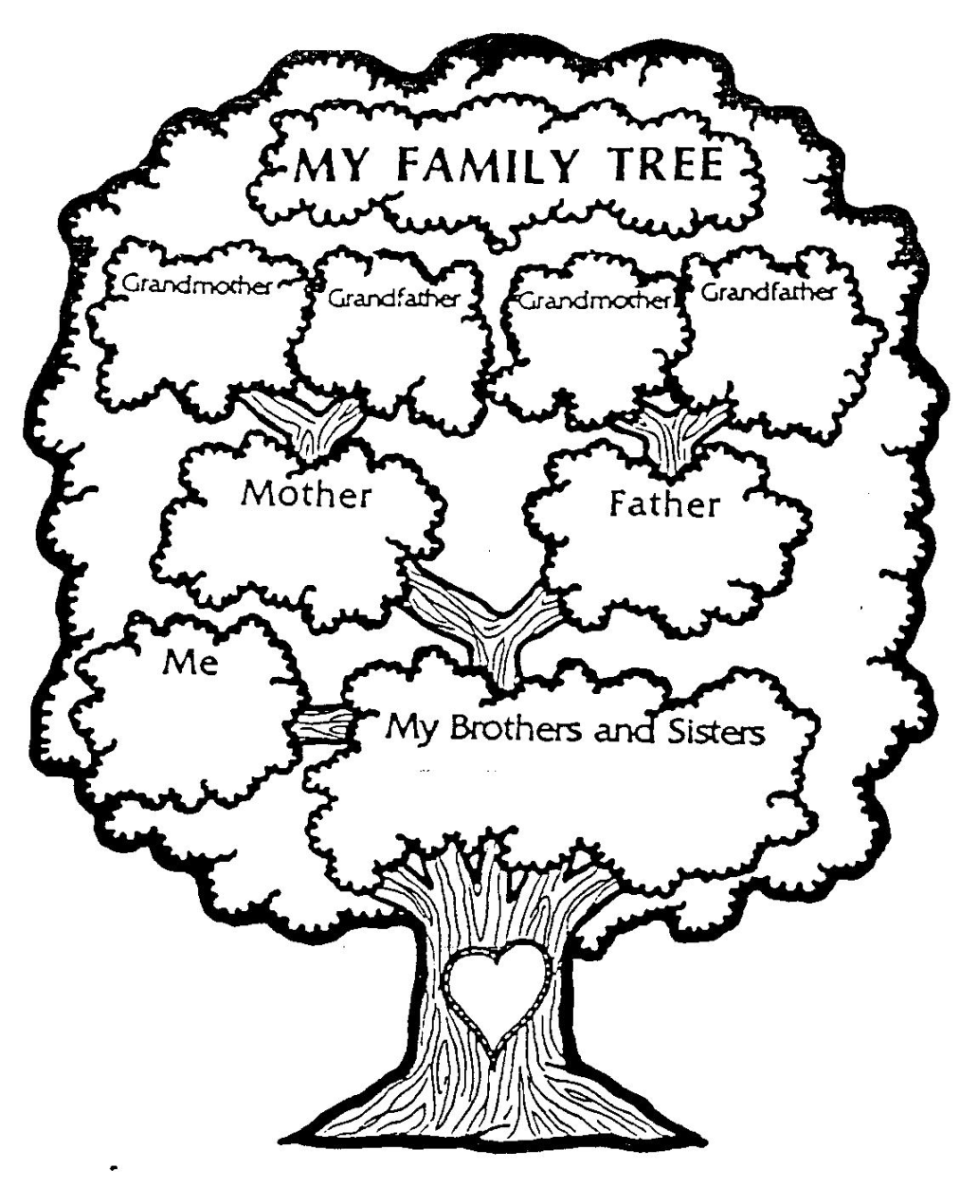

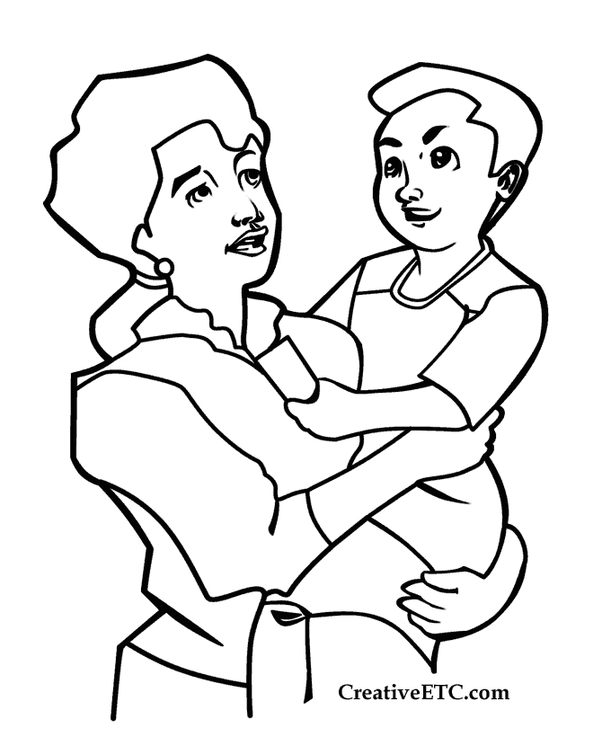 | Mother

Father | 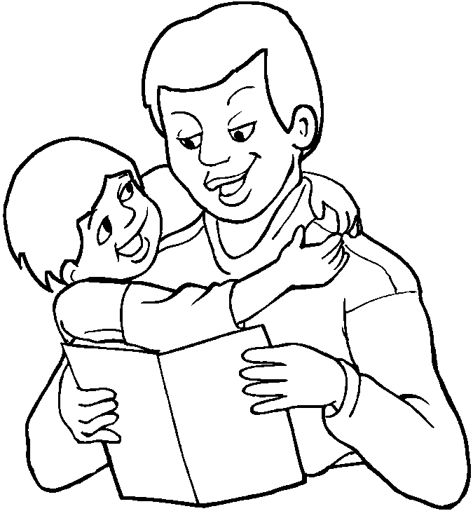

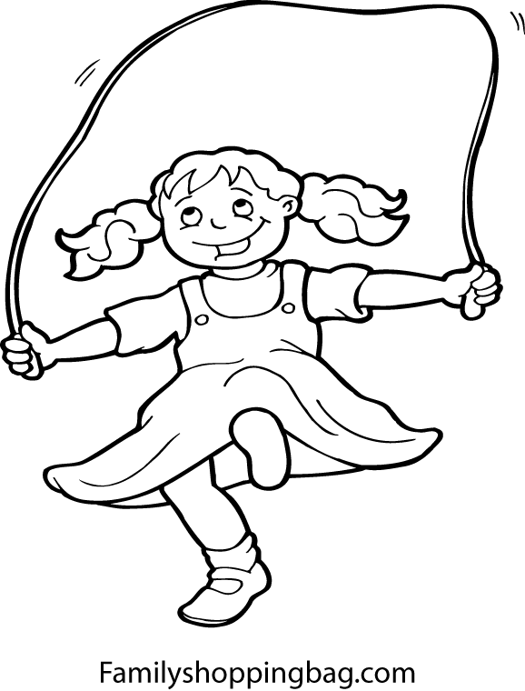 | Daughter

Son | 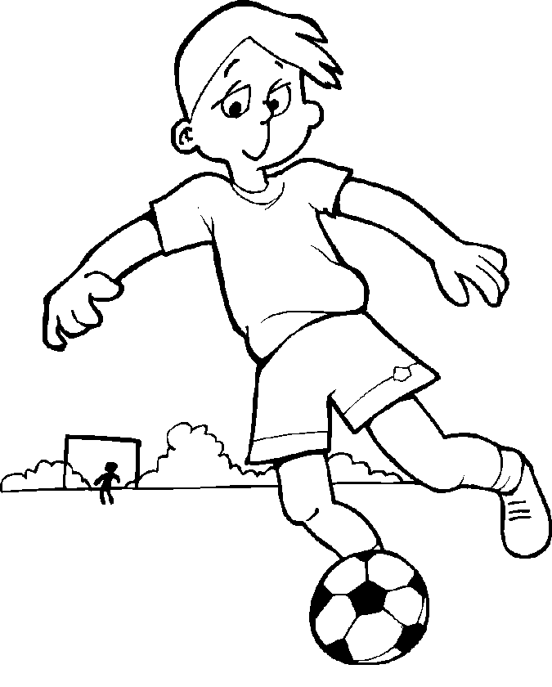

Grandmother | 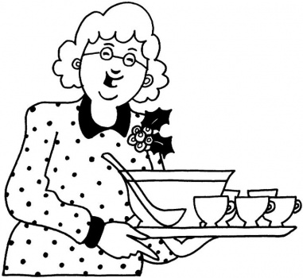

Grandfather | 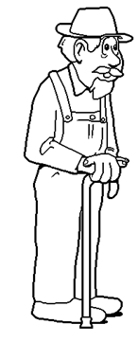
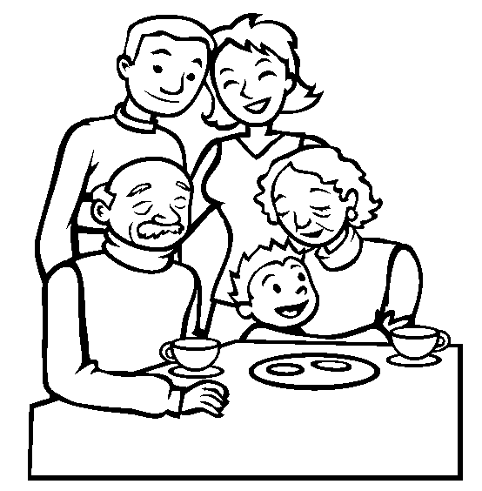

Colour in:
Father has brown hair.
Mother has red vest.
Grandfather has blue sweater.
Son has black hair.
Grandmother has green sweater.
Mother has blond hair.
Father has orange pullover.
Grandparents have grey hair.

